D.K.T.E. Society’s Textile and Engineering Institute, Ichalkaranji.

(An Autonomous Institute, Affiliated to Shivaji University, Kolhapur)

Department of Information Technology

2019-2020



**Project report on**

**Detecting Traffic Rules Violation**

**Under The Guidance Of**

**Dr. S. K. Shirgave**

**Submitted By:**

* **Magdum Pooja Suresh 16UIT41029XX**
* **Mujawar VasimDagadu 17UIT72006XX**
* **Nawale Pratiksha Ramesh 17UIT71008XX**
* **Niprul Snehal Anil 17UIT71009XX**
* **Phule Aamrapali Sanjay 17UIT71012XX**

Prof. S.K.Shirgave Prof. (Dr.) D. V. Kodavade

[Project Guide] [Head of the Department]

Prof. (Dr.) P.V. Kadole

[Director]



YEAR 2019-2020

DEPARTMENT OF INFORMATION TECHNOLOGY

CERTIFICATE

This is to certify that the project report title “**Detecting traffic rules violation**” is record of project work carried out in this college by,

* **Magdum Pooja Suresh 16UIT41029XX**
* **Mujawar Vasim Dagadu 17UIT72006XX**
* **Nawale Pratiksha Ramesh 17UIT71008XX**
* **Niprul Snehal Anil 17UIT71009XX**
* **Phule Aamrapali Sanjay 17UIT71012XX**

In partial fulfillment of the requirement for degree of BACHELOR OF

TECHNOLOGY in INFORMATION TECHNOLOGY of D.K.T.E. Society’s Textile and Engineering Institute, Ichalkaranji. This project report is record of their own work carried out under my supervision and guidance during academic year 2019-2020.

Prof. S.K.Shirgave Prof. (Dr.) D. V. Kodavade

[Project Guide] [Head of the Department]

Prof. (Dr.) P.V. Kadole

[Director]

**DECLARATION**

We hereby declare that, the project work report entitled “**Detecting Traffic Rules Violation**” which is being submitted to D.K.T.E. Society’s Textile and Engineering Institute Ichalkaranji, An Autonomous Institute affiliated to Shivaji University, Kolhapur is in partial fulfillment of degree B.Tech (I.T.). It is a bonafide report of the work carried out by us. The material contained in this report has not been submitted to any university or institution for the award of any degree. Further, we declare that we have not violated any of the provisions under Copyright and Piracy/Cyber/IPR Act amended from time to time.

**Name**  **Roll** **Number** **Signature**

* **Magdum Pooja Suresh 16UIT41029XX**
* **Mujawar Vasim Dagadu 17UIT72006XX**
* **Nawale Pratiksha Ramesh 17UIT71008XX**
* **Niprul Snehal Anil 17UIT71009XX**
* **Phule Aamrapali Sanjay 17UIT71012XX**

**ACKNOWLEDGMENT**

With great pleasure we wish to express our deep sense of gratitude to Prof. S. K. Shirgave for his valuable guidance, support and encouragement in completion of this project report.

Also, we would like to take opportunity to thank our head of department Dr. D. V. Kodavade for his cooperation in preparing this project report.

We feel gratitude to record our cordial thanks to other staff members of Information Technology department for their support, help and assistance which they extended as the when required.

Thank you,

**Name**   **Roll Number**

* **Magdum Pooja Suresh 16UIT41029XX**
* **Mujawar VasimDagadu 17UIT72006XX**
* **Nawale Pratiksha Ramesh 17UIT71008XX**
* **Niprul Snehal Anil 17UIT71009XX**
* **Phule Aamrapali Sanjay 17UIT71012XX**

**ABSTRACT**

* With the growth of number of vehicles, the number of traffic accidents is rapidly rising. Therefore, it is important to capture traffic violation to ensure traffic safety and reduce traffic accidents.
* Traffic violations are the most important cause of accidents. This system can effectively capture violations. It helps drivers strengthen awareness of safety when driving and ensure smooth traffic flow.
* Statistics of road accident :

2018 saw a total of 4.61K road accidents across India as compared to 4.65K in 2017. Though the number of road accidents have dipped marginally, the same cannot be said where road fatalities are concerned. This figure which stood at 1.51K in 2016, dipped to 1.48K in 2017, which went up to 1.49K in the past year.

**INDEX**

**Contents Page**

1. **Introduction 8**

1.1) Problem Definition

1.2) Need of the project with motivating example

1.3) Objective of project

1.4) Scope & limitations of project

1.5) Timeline for project

1.6) Cost of project

1. **Background study and Literature Review 13**

2.1) Technology review

2.2) Literature review

1. **Requirement Analysis 15**

3.1) Functional Requirements

3.2) Non Functional Requirements

3.3) Hardware Requirements

1. **System Design 17**

4.1) Architectural Diagram

4.2) Usecase Diagram

4.3) Data Flow Diagram

4.3.1) level zero

4.3.2) level one

1. **Software Testing 21**
   1. Integration test cases generation and its testing reports
   2. System test cases generation and its testing reports
2. **Screenshots of projects 23**
3. **Performance Analysis 34**

1. **Application 35**
2. **Conclusion 36**
3. **Installation guide and user manual 37**
4. **References 39**

1. **INTRODUCTION**
   1. **Problem Definition**

Implement System to detect traffic rules violation.

* 1. **Need of the project with motivating example**

The cause of maximum number of road accidents was reported to be over speeding, violating traffic rules and rash driving — about 403 such cases were reported in which 227 people died and 397 were injured.

The second highest number of road accident cases in State is due to people’s tendency of driving on the wrong side and not wearing helmet. About 112 road accidents cases have been reported under this category, in which 62 people were killed and 115 were injured.

Third major cause of road accidents in Uttarakhand is people wrongly overtaking the vehicle moving ahead and not using helmet while traveling. Which caused about 96 accidents in which 54 people lost their lives and 103 were injured.

According to the report titled “Road Accident Analysis in Tamil Nadu March 2019”, out of the 978 persons killed in the accidents involving two-wheelers, 508 riders and pillion riders did not wear a helmet. About 52 per cent of the death in two-wheelers were occurred due to non-wearing of helmets.

A year after motorcycle crash, Jim Lumley still thanks his helmet: A Northern Express Apr. 29, 2013, article wherein Jim explains he is glad he was wearing his helmet at the time he was involved in a low-speed crash even though the law in Michigan had changed the year before to make wearing a helmet optional. The low-speed crash turned out to be high-stakes for Lumley, who suffered a serious injury to his knee. He also believes he owes his life to the helmet that cracked when it hit the windshield. It was a high-end, $350 helmet, with an air cushion that inflated to further protect his head. The helmet was destroyed in the crash. “Literally, I could have legally been riding without a helmet, but I chose to wear a helmet,” he said.

Hence to avoid this accidents our system is very useful.

* 1. **Objective of Project**

The goal of the project is to automate the traffic rules violation detection system and make it easy for the traffic police department to monitor the traffic and take action against the violated vehicle owner in a fast and efficient way.

The violations such as

* Sign detection
* More than two people on a motorcycle i.e. triple seat detection
* Helmet wear or not

**1.4 Scope & limitations of the project**

**1.4.1 Existing System:**

Different traffic rule violation detection devices are available in the market as follows:

1. Traffic detection system using Android.
2. Violation Detection at Traffic Signals using RFID System.
3. Detecting traffic light signals.

**1.4.2 Limitations:**

**The existing system has the following limitation:**

* Manual work.
* No mechanism for tracking jobs.
* No streamline methodology/features for payment

**1.4.3 Scope:**

The system can be designed by considering the new technology. In future this project can be linked with IOT where all the data can be shared among the RTO offices and penalties can be charged to violators. The system can also be linked with RFID communication more efficiently.

**1.5 Timeline for project**

|  |  |  |  |  |  |
| --- | --- | --- | --- | --- | --- |
| Sr. no | Work | Start Date | End Date | Work in hrs. | Status |
| 1 | Area Finalization | 22/7/19 | 28/7/19 | 30 hrs. | Completed |
| 2 | Information Gathering & Literature Survey | 28/7/19 | 12/8/19 | 30 hrs. | Completed |
| 3 | Design, Analysis | 14/8/19 | 5/9/19 | 60 hrs. | Completed |
| 4 | Module 1: Number Plate Detection | 15/9/19 | 5/10/19 | 30 hrs. | Completed |
| 5 | Module 2: Sign Detection | 5/1/20 | 15/1/20 | 30 hrs. | Completed |
| 6 | Module 3: Helmet Wear Or Not Detection | 15/1/20 | 25/1/20 | 30hrs | Completed |
| 7 | Module 4: More Than Two People On A Motorcycle i.e. Triple Seat Detection | 26/1/20 | 7/2/20 | 30 hrs. | Completed |
| 8 | Module 5: Website Design | 9/2/20 | 16/2/20 | 20 hrs. | Completed |
| 9 | Module 1 Testing | 18/2/20 | 25/2/20 | 12 hrs. | Completed |
| 10 | Module 2 Testing | 26/2/20 | 5/3/20 | 20 hrs. | Completed |
| 11 | Module 3 Testing | 6/3/20 | 10/3/20 | 15 hrs. | Completed |
| 12 | Module 4 Testing | 13/3/20 | 20/3/20 | 16 hrs. | Completed |
| 13 | Module 5 Testing | 22/3/20 | 28/3/20 | 18 hrs. | Completed |
| 14 | Integration of Module and Testing | 13/3/20 | 14/4/20 | 30 hrs. | Completed |
| 15 | Final Documentation |  |  |  |  |

**1.6 Cost of project:**

|  |  |  |  |  |  |
| --- | --- | --- | --- | --- | --- |
| Sr. No. | Equipment |  | Details |  | Price(Rs) |
| 1. | Electricity |  | Consumed | 40 units | 120 |
| 2. | Internet |  | 50 GB |  | 2500 |

Estimated cost by considering other factors will be approx. **- Rs. 2620/**

**COCOMO Model:**

In this project the Cost Estimation based on COCOMO (Constructive Cost Model) the formula for the this Model is follows

Effort = Constant × (Size) scale factor× Effort Multiplier

* Effort in terms of person-months
* Constant: 2.45 in 1998 based on Organic Mode
* Size: Estimated Size in KLOC
* Scale Factor: combined process factors
* Effort Multiplier (EM): combined effort factors

Functional Point Table

The function point range in between 1-10

|  |  |  |  |
| --- | --- | --- | --- |
| Number of FP | Complexity |  |  |
| External User Type | Low | Average | High |
| External input type | 4 | 6 | 9 |
| External output type | 5 | 7 | 9 |
| Logical internal file type | 4 | 6 | 9 |
| External interface file type | 5 | 8 | 10 |
| External inquiry type | 4 | 6 | 8 |
| Total | 33 |  |  |

Conversion of Functional point to Lines of Code (LOC)

Total function points = 33

■ Estimated Size – 200 LOC

The basic COCOMO equations take the form

Effort Applied (E) = ab(KLOC)bb [ man-months ]

Development Time (D) = cb(Effort Applied)db [months]

People required (P) = Effort Applied / Development Time [count]

Where, KLOC is the estimated number of delivered lines (expressed in thousands) of code for project. The coefficients ab, bb, cb and db are given in the following table

|  |  |  |  |  |
| --- | --- | --- | --- | --- |
| Software  Project | ab | bb | cb | db |
| Organic | 2.4 | 1.05 | 2.5 | 0.38 |
| Semidetached | 3.0 | 1.12 | 2.5 | 0.35 |
| Embedded | 3.6 | 1.20 | 2.5 | 0.32 |

Organic Mode

EFFORT = 2.4 x (8.12)*1.05 =20.46

Development Time= 2.5 x (3)*0.38 = 3.79

People required = 20.46/3.79= 5 people

**2. BACKGROUND STUDY AND LITERATURE REVIEW**

**2.1 TECHNOLOGY REVIEW**

Literature survey is the most important step in software development process. Before developing the tool, it is necessary to determine the time factor, economy. Once these things are satisfied, then next steps are to determine which operating system and language can be used to developing the tools. Once the programmer start building the tool the programmer need lots of external support. This support can be obtained from senior friends, teachers, from book or from websites. Before building the system, the above consideration are taken into account for developing the proposed system

**2.2 LITERATURE REVIEW**

According to the increasing population of peoples and vehicles on the road used by those peoples, there are many issues created like traffic violation on road, security of peoples from accidents, increasing accidents on the roadside and also increasing the workload of traffic police and government too. Surveys carried out by experts have mentioned different traffic rule violation detection devices. Traffic rule violation tasks include:

* Sign detection
* More than two people on a motorcycle i.e. triple seat detection
* Helmet wear or not

**We can see the papers as mentioned below:**

[1] In this paper, a system for traffic violation alert and management has been presented. The proposed hardware architecture combines an on

-board computer vision system for traffic sign detection and a data recorder for managing traffic violations. The warnings come in the form of acoustical messages emitted through the vehicle loudspeakers, and they are issued with sufficient time to provide the driver with enough notice to react to the on

-coming traffic situation.

[2] This paper have presented a traffic-monitoring approach for vehicle tracking based on rule-based analysis. The system pattern is structured between the low-level image processing modules that is used for extracting visual data of vehicles under various illumination circumstances and the high-level image processing module that provides a general-purpose knowledge-based framework for tracking vehicles in the scene. Based on adequate image-analysis algorithms, the low level image-processing modules extract vehicles from the current frame. The high-level processing module is developed as a forward chaining production system

[3] This paper aims to give an idea about the number of traffic offenders in an area. It generates a database of all the bike rides driving without wearing a helmet along a snapshot for proof. Use of Open and free technologies like tensorflow, opencv and tesseract, makes the software relatively less expensive. Under fair lighting conditions, this system was tested to give fool proof results.

**3. REQUIREMENT ANALYSIS**

Requirements are features that the system will need in order to deliver or operate. In the case of this project, it was important to gather some requirements that will be needed to achieve the objectives set out previously. With client (user) story a use case analysis was implemented which resulted in the following functional and non-functional requirements were captured. The functional requirements have been gathered from the user story developed from the minutes collected during meetings with the client and are outlined here.

**3.1 Functional requirements**

**1) Number Plate Recognition**

**Input**: - Number plate image

**Description**: - System takes an image of the number plate as input. Extract number from image and compares this number with a number stored in the file. If the violation has occurred by the vehicle.

**Output**: - Number plate of violated vehicle.

**Constraint**: - Image should be clear.

**2) Triple seat detection**

**Input**: - Video

**Description**: - System detects violations if more than two persons are on the vehicle. For this, the system will compare input images with a trained dataset.

**Output**: - Triple seat violation detect.

**Constraint**: - video should be clear.

**3) Helmet detection**

**Input**: - Video

**Description**: - The system will check whether the person is wearing a helmet or not. For this system will compare the image with a trained dataset

**Output**: - Helmet detection violation detect

**Constraint**: - video should be clear.

**4) Sign detection**

**Input**: - Video

**Description**: - System will check the signs present on-road and make highlights with a green rectangle.

**Output**: - Sign detection

**Constraint**: - video should be clear.

**5) Feedback system**

**Input**: - User details based on the number plate capture and violation status.

**Description**: - System will display an alert message to the owner.

**Output**:-Alert message sent to the user.

**Constraint**: - Image of number plate and owners details should be appropriate which will helpful for send alert message.

**3.2 Nonfunctional requirements**

**Reliability**:

The System must give an accurate status of the violation. The System must successfully detect the traffic rule violations and take appropriate action against the driver of the bike efficiently.

**3.3 Hardware and other Requirement**

**Hardware Requirements**

* Ram: 8GB Ram
* processor: i5 and more
* Camera

**Operating System Requirements**

* Windows

**Tools and Technologies Requirements**

**Tools**:-

* Anaconda
* Notepad++
* Bracket

**Technology**:-

* Python OpenCV
* Machine Learning
* Web Technology
* Eel python

**4**. **SYSTEM DESIGN**

**4.1 Architecture Diagram:**

Figure 4.1 shows the architectural design of the system. It shows how our system modules will work. The first module is image recognition which starts the system by capturing images. Then according to the type of violation appropriate action will be taken against the person.

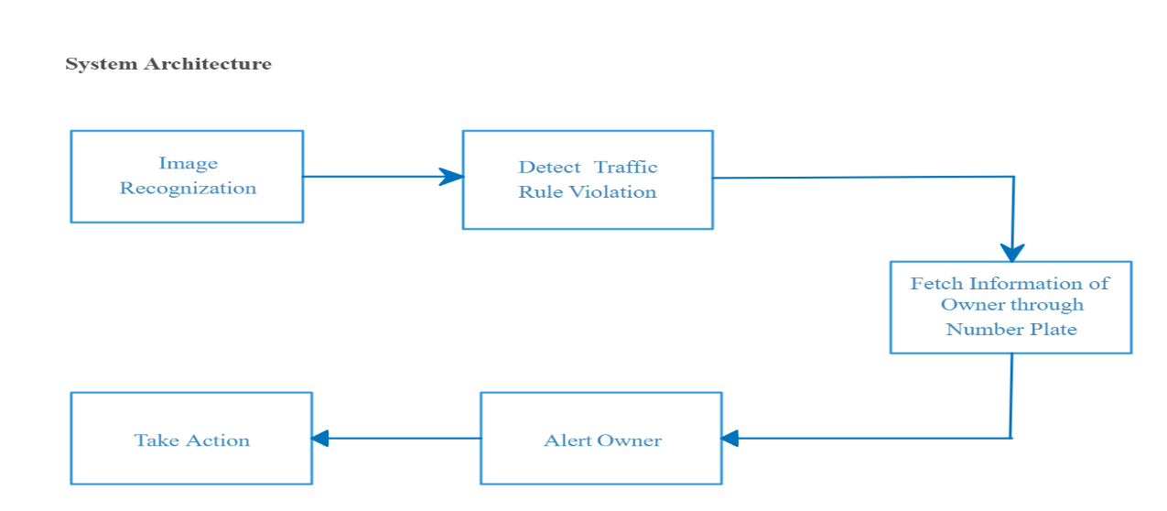

Figure 4.1: Architecture Design

**4.2 Usecase Diagram:**

Figure 4.2 shows Usecase diagram. It has two actors as:

1. User
2. Traffic rule detection system

When user will do one of the violations such as triple seat, helmet detection, sign detection then traffic rules violation detection system will do image recognition of number plate. By identifying owner through number plate system gets owner information. Once owner details get captured the feedback system will send an alert message to the registered owner and notify the violation status.

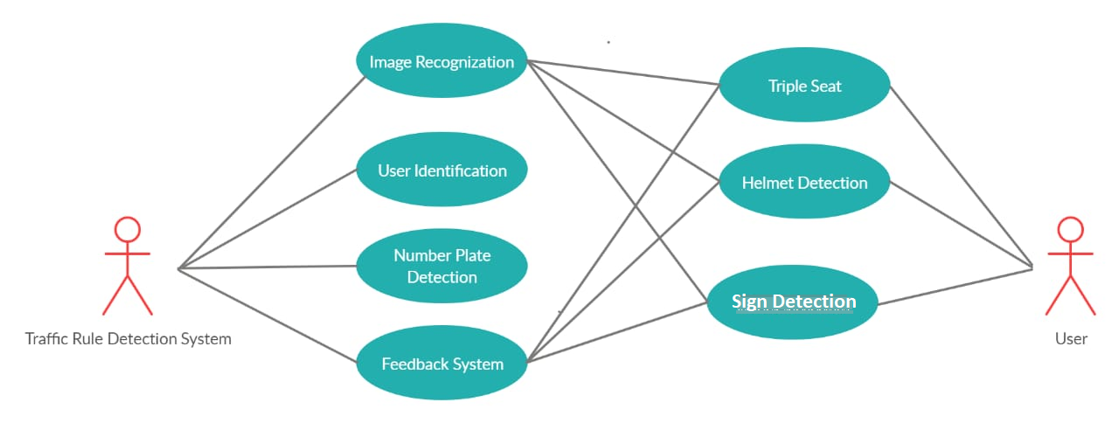

Figure 4.2: Usecase Diagram



**4.3 Data Flow diagram**

**4.3.1 Level 0**

Figure 4.3.1 shows level 0 Data flow Diagram. The image or video is given as input to the system. The traffic rules detection system will detect all the violations as mentioned above by fetching the owner's detail from the number plate, violation status will be sent to the owner of the vehicle/motorcycle with an alert message.

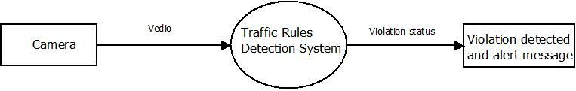

Fig 4.3.1: level 0 Data flow Diagram

**4.3.2 Level 1 Data flow diagram**

Figure 4.3.1.2 shows the level 1 Data flow diagram. Which shows the internal models of the system. It includes:

● Number plate detection

● Sign detection

● Triple seat detection

● Helmet detection

Traffic violation detection system takes video as input. When the system found any one of the violations, it takes the number plate of the violated vehicle to fetch owner details such as owner name, city, mobile number, number on number plate that is stored in the file. To send the alert message to the owner of the vehicle, the System will fetch the mobile number and name of the owner that is linked with the number plate and sends an appropriate alert message.

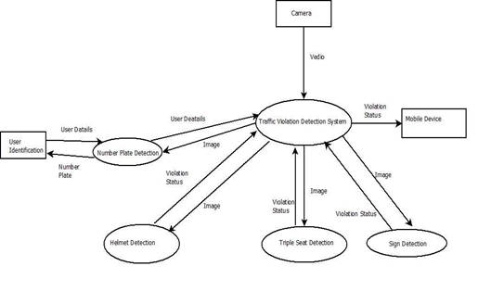

Figure 4.3.2: level 1 Data flow diagram

**5. SOFTWARE TESTING**

**Helmet wear or not:**

* After passing the video in which the person is wearing a helmet, System will not send an alert message to the owner. The system will show only a popup message as “You are not violating traffic rule”.
* After passing the video in which the person is not wearing a helmet, the System will show a popup message as “You are violating traffic rule”. As well as send an alert message to the owner about the violation.
* When a person violates a rule, the system captures a number plate of the bike. By using that number extract the owner details from the file. Owner details such as the name of the owner and mobile number. That all information it displays as output is shown in the figure below.

**More than two people on bike:**

* After passing the video in which there is a single person on a bike, System will not send an alert message to the owner. The system will show only a popup message as “You are not violating traffic rule”.
* After passing the video in which there are more than two persons on a bike, the system will show a popup message as “You are violating traffic rule”. As well as send an alert message to the owner about the violation.
* When a person violates a rule, the system captures a number plate of the bike. By using that number extract the owner details from the file. Owner details such as the name of the owner and mobile number. That all information it displays as output is shown in the figure below.

**Sign detection:**

* After passing the video as input system will check the signs present on-road and make highlights with a green rectangle.

**5.1 Integration test cases generation and its testing reports**

|  |  |  |  |  |  |
| --- | --- | --- | --- | --- | --- |
| Test case No | Test case | Input | Expected  Output | Actual Output | Status |
| 01 | Helmet wear or not | video | Person who does not wear the helmet will be detected. | Helmet detection violation is detected. | Pass |
| 02 | More than two people on bike | video | If more than two people on bike are there it will be detected. | Triple seat rule violation is detected. | Pass |
| 03 | Sign detection | Video/images | Appropriate sign will be detected. | Sign detected successfully. | Pass |

**5.2 System test cases generation and its testing reports**

|  |  |  |  |  |  |  |  |  |  |
| --- | --- | --- | --- | --- | --- | --- | --- | --- | --- |
| Test case No | Test case |  | Input |  | Expected  Output |  | Actual Output |  | Status |
| 01 | Alert owner of bike |  | Violated images |  | Message should be send to owner. |  | Message is sent. |  | Pass |

**6. SCREEN SHOT**

**Home Page:** It is the main page of the Detecting Traffic Rules Violation system.

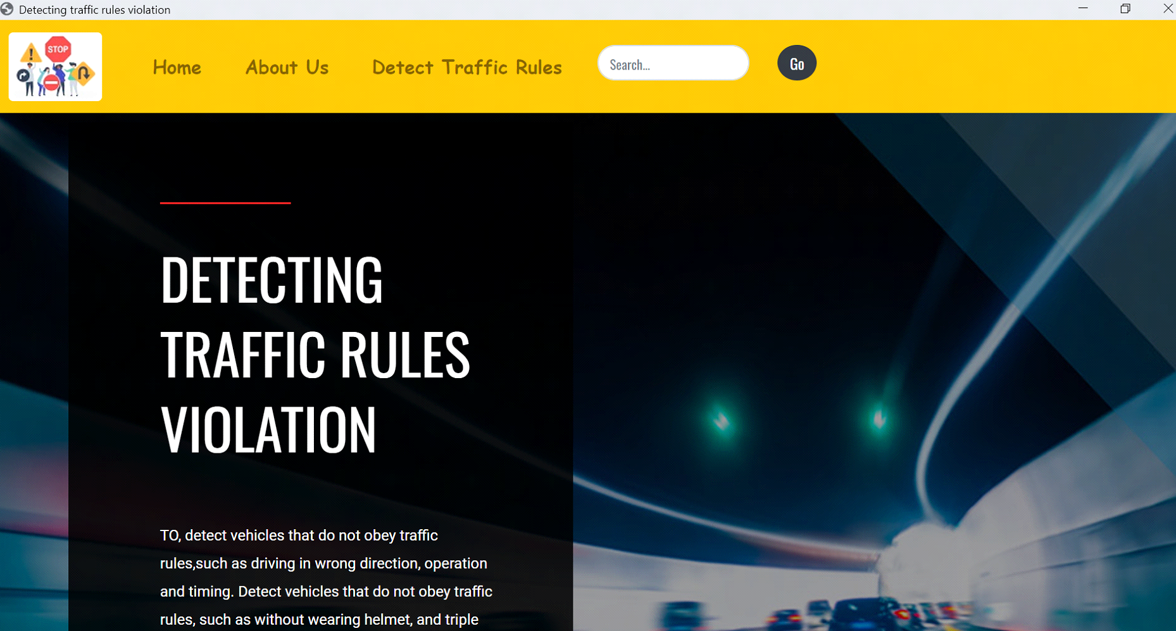

**About us page:**

It includes some information about our Traffic Rule Violation Detection system and group members.

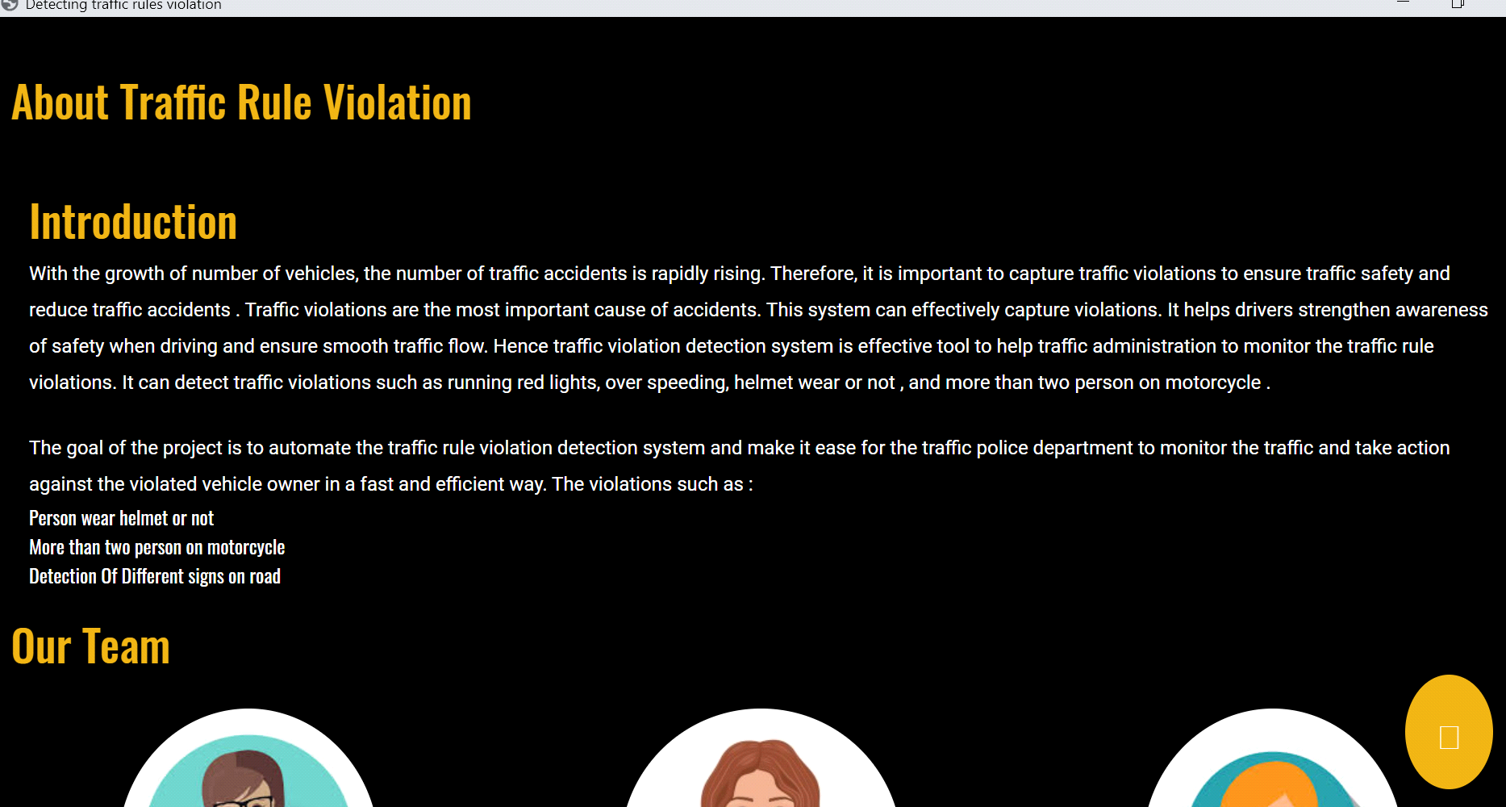

**Detection System Page:**

On this web page, there are different components to make interaction with the different modules of the system. It includes three modules helmet detection, triple seat detection, and sign detection. The user will have to first choose a video for which he is going to test violation status. The system will test the violation and alert the vehicle owner about the violation.

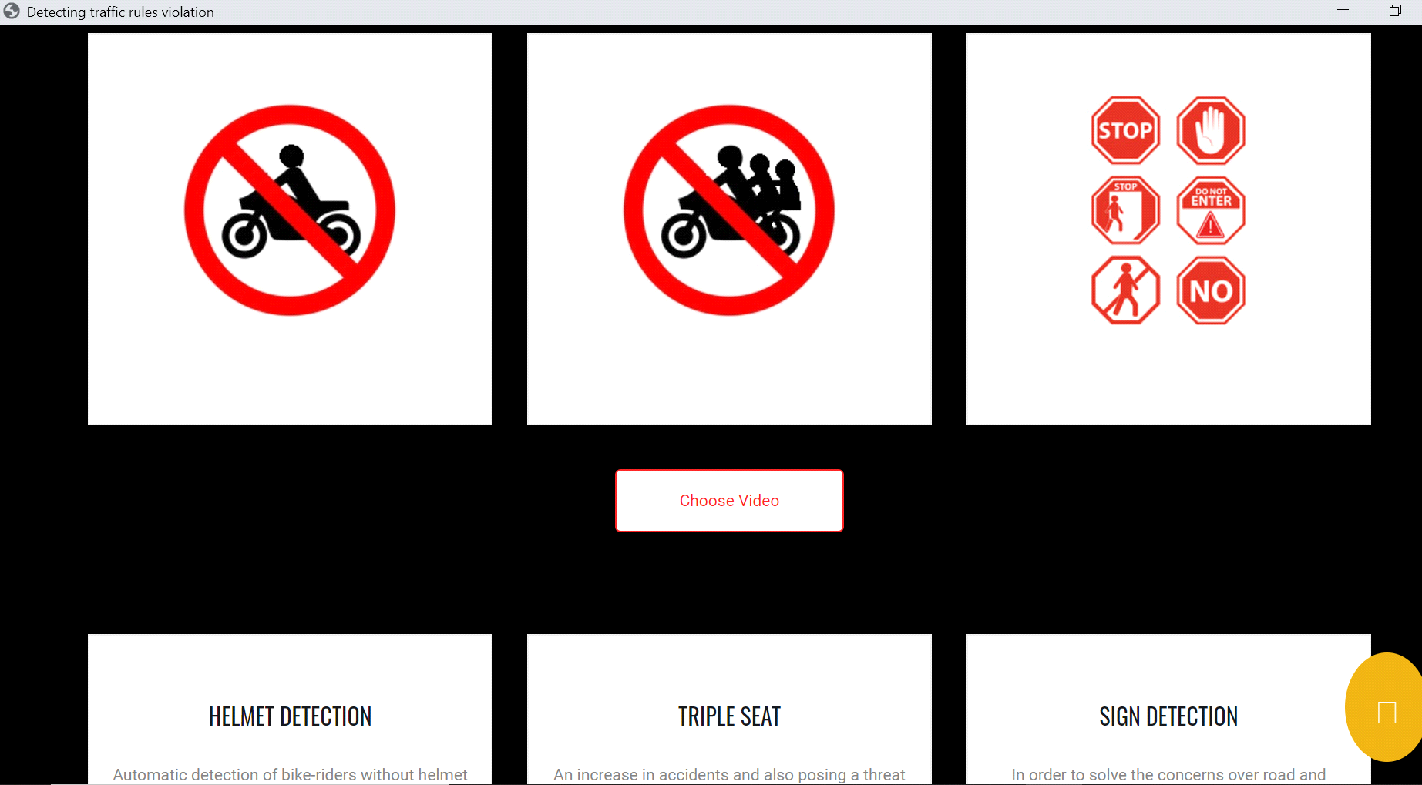

**Helmet Detection:**

After passing the video in which the person is wearing a helmet, System will not send an alert message to the owner. The system will show only a popup message as “You are not violating traffic rule”.

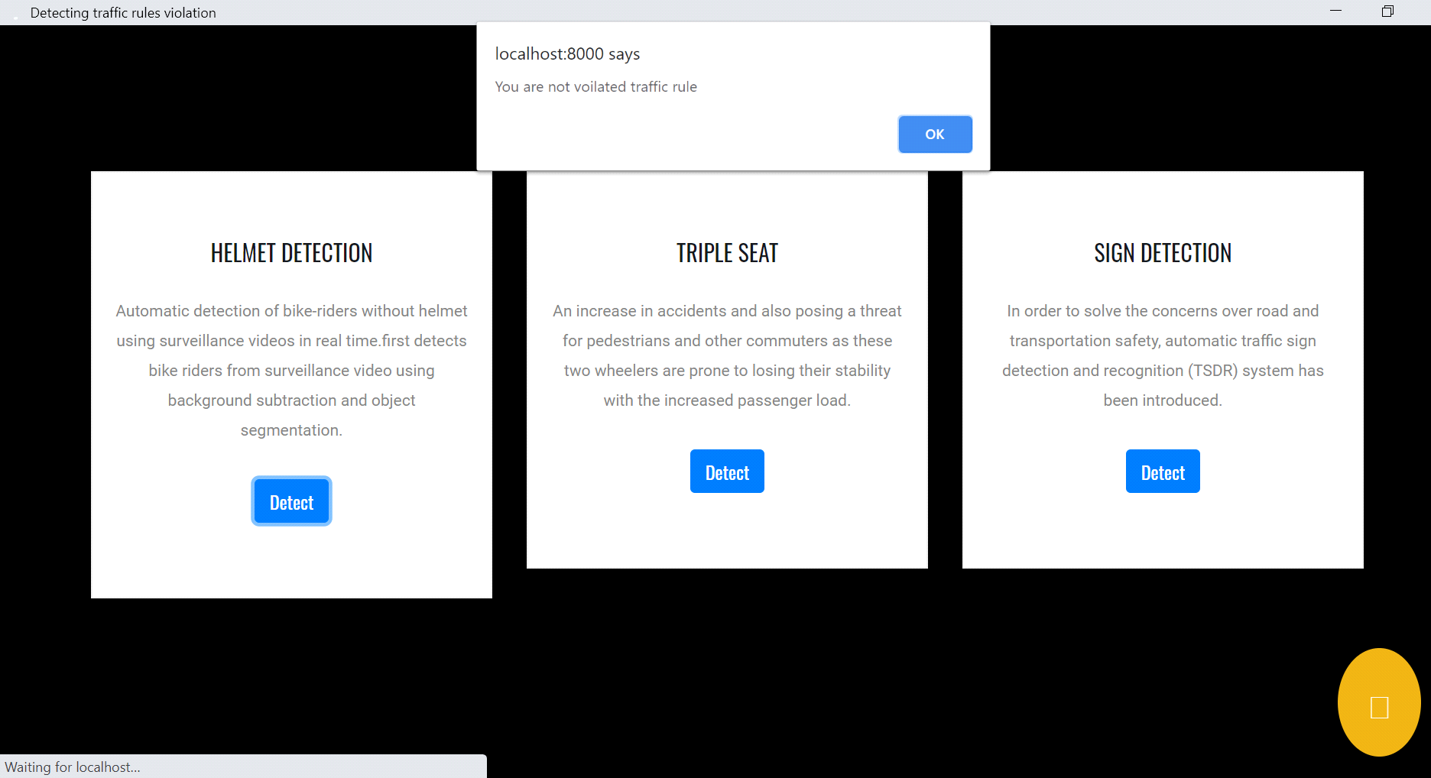

After passing the video in which the person is not wearing a helmet, the System will show a popup message as “You are violating traffic rule”. As well as send an alert message to the owner about the violation.

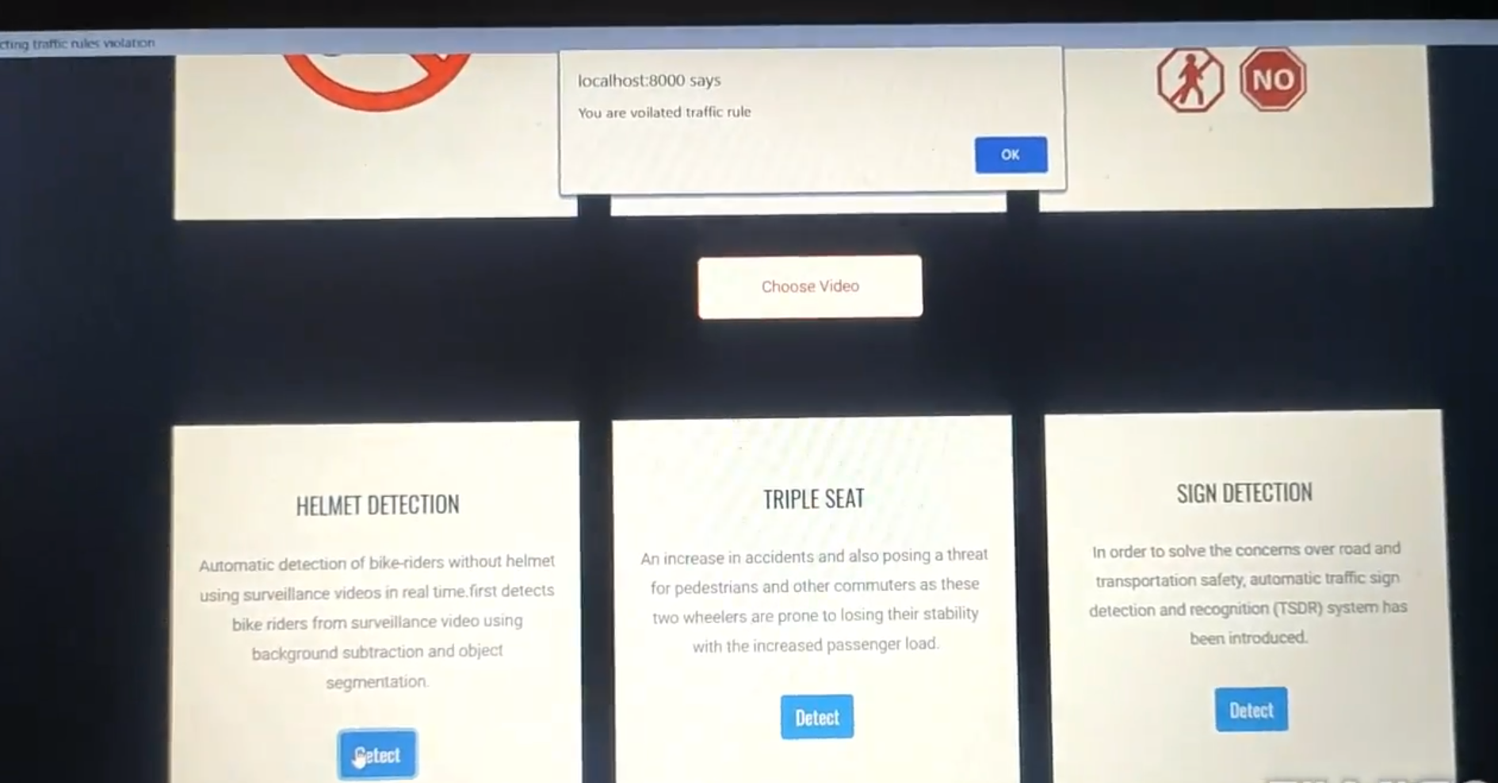

**Output:**

When a person violates a rule, the system captures a number plate of the bike. By using that number extract the owner details from the file. Owner details such as the name of the owner and mobile number. That all information it displays as output is shown in the figure below.

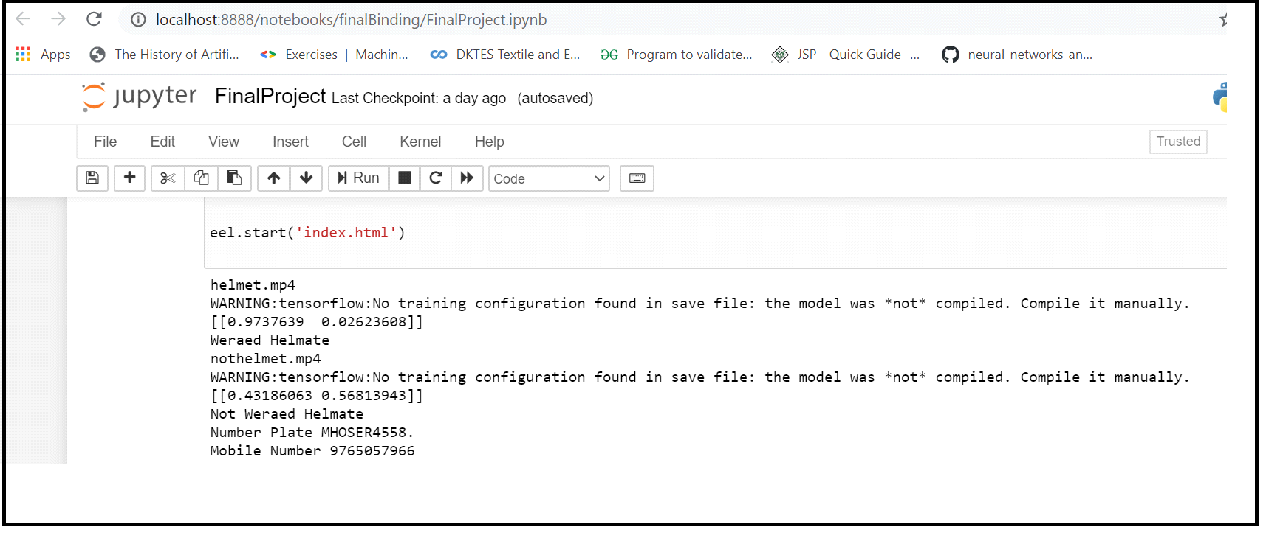

**Sign Detection:**

After passing the video as input system will check the signs present on-road and make highlights with a green rectangle.

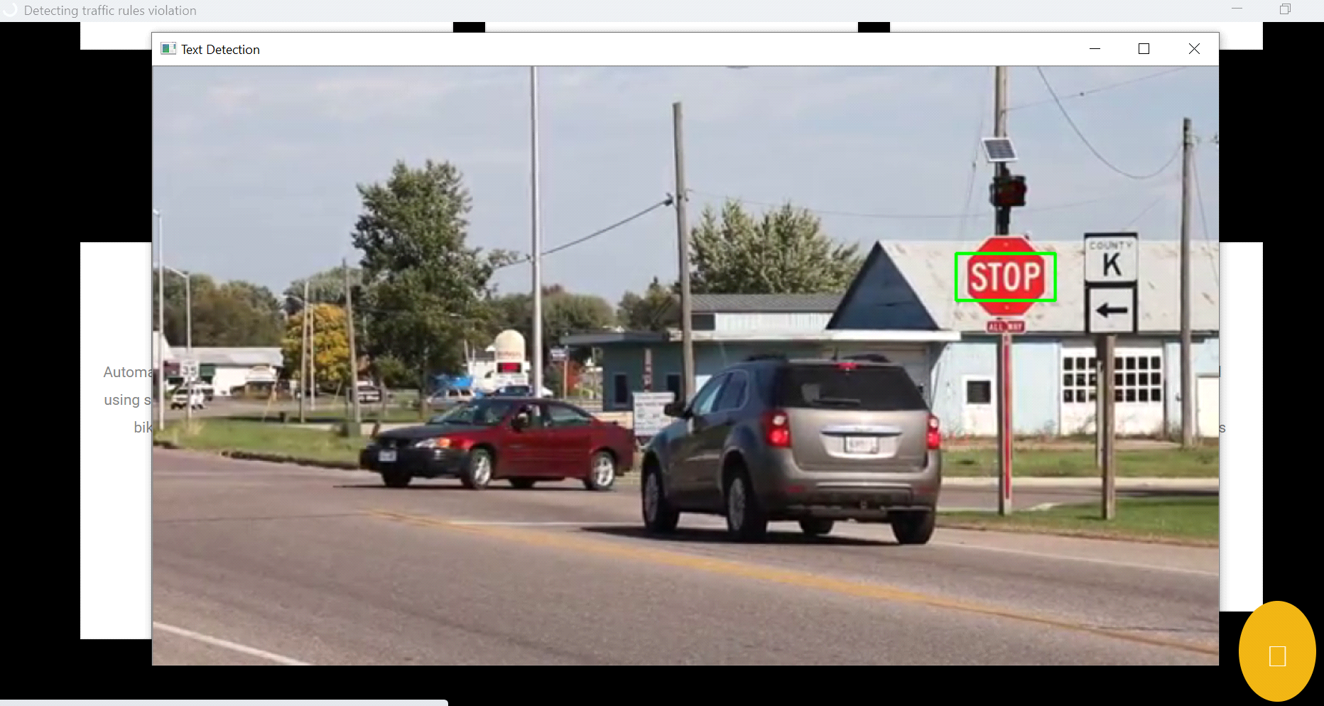

**Triple Seat Detection:**

After passing the video in which there is a single person on a bike, System will not send an alert message to the owner. The system will show only a popup message as “You are not violating traffic rule”.



After passing the video in which there are more than two persons on a bike, the system will show a popup message as “You are violating traffic rule”. As well as send an alert message to the owner about the violation.



**Output:**

When a person violates a rule, the system captures a number plate of the bike, which is having owner details such as the name of the owner and mobile number. That all information displayed as output. Which shown in the figure below.

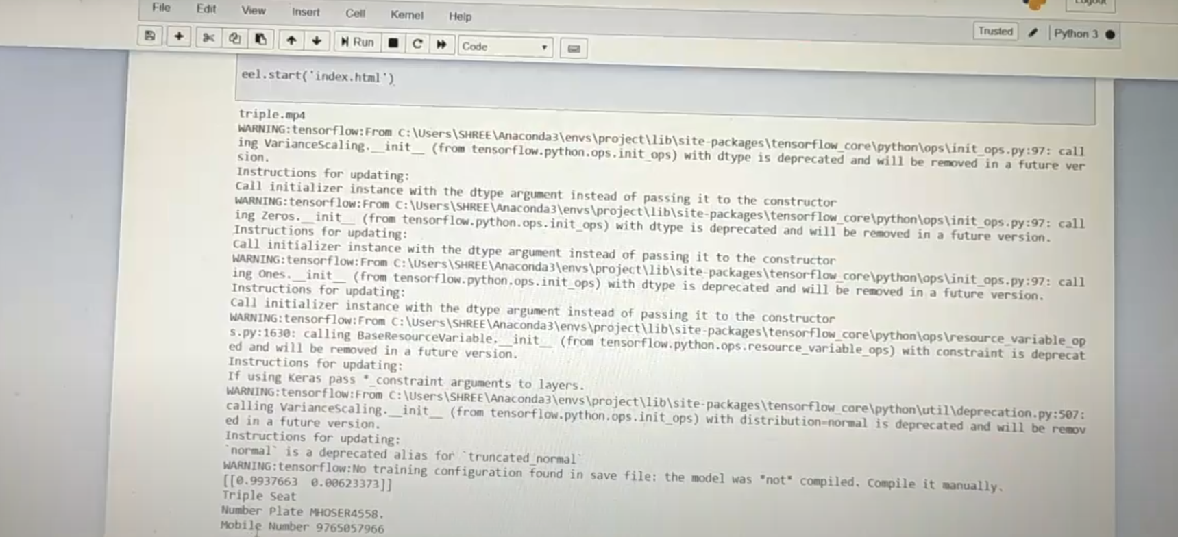

**Alert Message to Person:**

The owner will get a violation alert in the form of a text message on the linked mobile number.

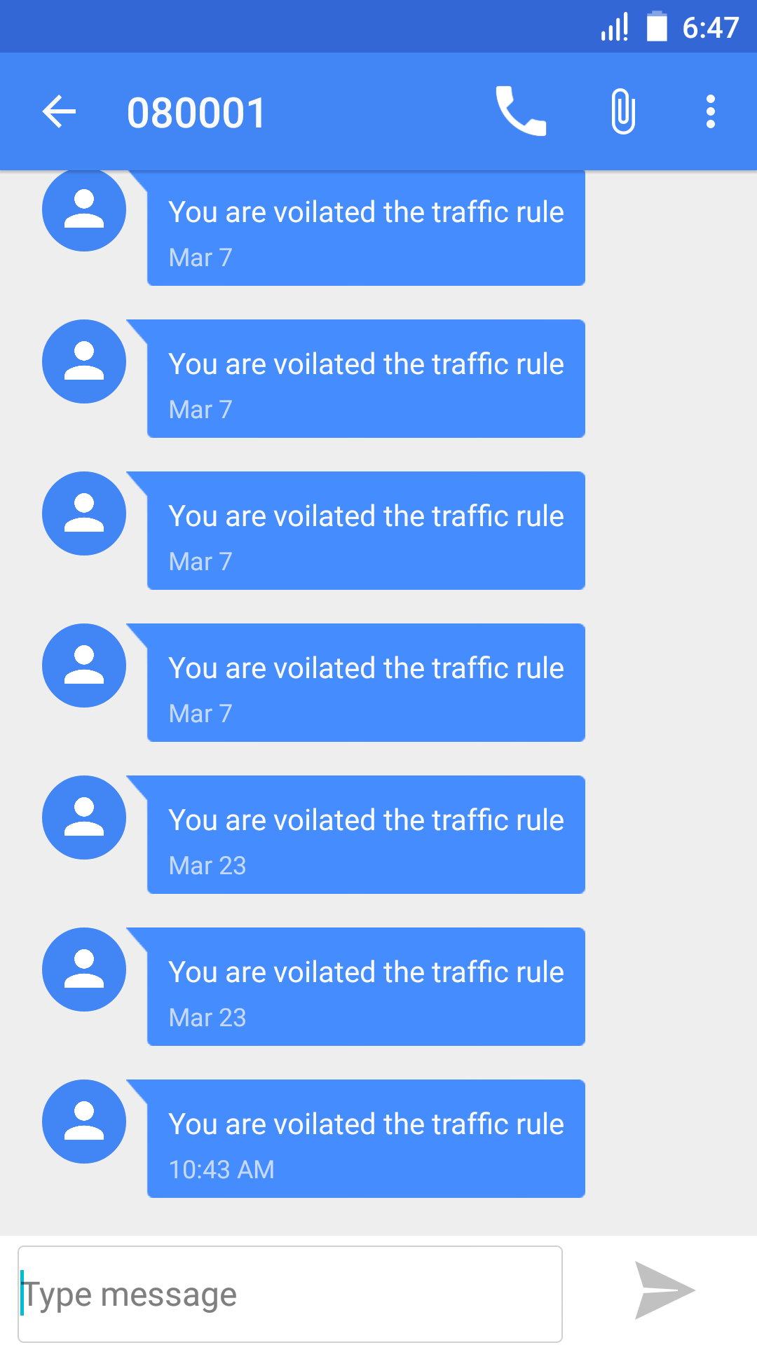

**7. PERFORMANCE ANALYSIS**

The project uses web technology and Python language to build the system. Using Web portal users can easily interact with the system. Users will get an immediate response to traffic rules violations. This system will work efficiently for detecting violations such as triple seat, a person wearing a helmet or not, and sign detection. The system correctly captures the violated images. The system has a 95% correct result in any circumstances.

**8. APPLICATIONS**

The system can be used…..

● RTO Office: Regional Transport Office (RTO) is an Indian government bureau that is responsible for the registration of vehicles and the issue of Driver’s License in India. RTO management will be having a lot of work regarding registration of vehicles and the issue of driver’s license. Similarly, the vehicle owner sometimes forgets to carry the license. This system will directly take the owner details from its number plate database and give the easiest and efficient way to efficiently get the owner's information.

● Motorcycle driving school: While issuing a driving license to the person, a sign detection module can be useful to see whether a driver follows traffic rules, and according to that test can be conducted.

● Crime reporting: In the case of a criminal case, this system will be helpful to catch the culprit from his location. If he migrates from one location to another, the system will have the track of all the places he visited, as the system captures video of vehicles.

**9. CONCLUSION:**

Continuous growth of population all over the world creates a great challenge to the transport management systems. The conventional methods are no longer effective enough for solving complex and challenging transportation management problems. Due to the increased amount of vehicles, it is necessary to take effective steps in order to control the traffic violations. This system overcomes most of the disadvantages of existing systems. The system can track violations effectively, and automatically save and display the information. It realizes intelligent traffic management. It enables a fast and accurate detection of the violations.

**10. INSTALLATION GUIDE AND USER MANUAL**

**Environmental settings for running the module**

Text Recognition is used in handwritten or printed text into machine-encoded text, whether from a scanned document, a photo of a document, a scene-photo or from subtitle text superimposed on an image. Following technique is used for the character detection and character recognition. As mentioned below.

1. OpenCV OCR with Tesseract
2. East Text Detector
   * + 1. **OpenCV OCR with Tesseract:**

Optical character recognition (OCR) is the recognition of printed or written text characters by a computer. This involves photo scanning of the text character-by-character, analysis of the scanned-in image, and then translation of the character image by the character codes, such as ASCII commonly used in data process.

**Installation steps:**

Prerequisites:

* Python-tesseract requires Python 2.7 or Python 3.5+
* You will need the Python Imaging Library (PIL) (or the [Pillow](https://pypi.org/project/Pillow/) fork.
* Install [Google Tesseract OCR](https://github.com/tesseract-ocr/tesseract). You must be able to invoke the tesseract command as tesseract. If this isn’t the case, for example because tesseract isn’t in your PATH, you will have to change the “tesseract_cmd” variable pytesseract.pytesseract.tesseract_cmd.
  + - 1. **East Text Detector:**

## EAST (Efficient accurate scene text detector):

EAST can detect text both in images and in the video. As mentioned in the paper, it runs near real-time at 13FPS on 720p images with high text detection accuracy. Another benefit of this technique is that its implementation is available in OpenCV 3.4.2 and OpenCV 4. We will be seeing this EAST model in action along with text recognition.

# Eel Python:

Eel is a little Python library for making simple Electron-like offline HTML/JS GUI apps, with full access to Python capabilities and libraries. **Eel hosts a local webserver, then lets you annotate functions in Python so that they can be called from Javascript, and vice versa.**

**To create runtime environment required library:**

* pip install opencv-python
* pip install pillow
* pip install pytesseract
* install tessractocr
* pip install eel
* pip install tensorflow
* pip install keras
* pip install utils
* pip install os
* pip install imultils
* pip install cv2

**11. REFERENCE:**

**IEEE-** **Papers:**

* [**https://ieeexplore.ieee.org/document/8343528**](https://ieeexplore.ieee.org/document/8343528)
* [**https://ieeexplore.ieee.org/document/7560926**](https://ieeexplore.ieee.org/document/7560926)
* [**https://ieeexplore.ieee.org/document/8646449**](https://ieeexplore.ieee.org/document/8646449)